Calculator.java
package com.example;
public class Calculator {
public int add(int a, int b) {
return a + b;
}
public int subtract(int a, int b) {
return a - b;
}
}

CalculatorTest.java
package com.example;
import org.junit.After;
import org.junit.Before;
import org.junit.Test;
import static org.junit.Assert.assertEquals;
public class CalculatorTest {
private Calculator calculator;
@Before
public void setUp() {
calculator = new Calculator();
}
@After
public void tearDown() {
calculator = null;
}
@Test
public void testAddition() {
int a = 10;
int b = 20;
int result = calculator.add(a, b);
assertEquals(30, result);
}
@Test
public void testSubtraction() {
int a = 20;
int b = 10;
int result = calculator.subtract(a, b);
assertEquals(10, result);
}
}
Output:
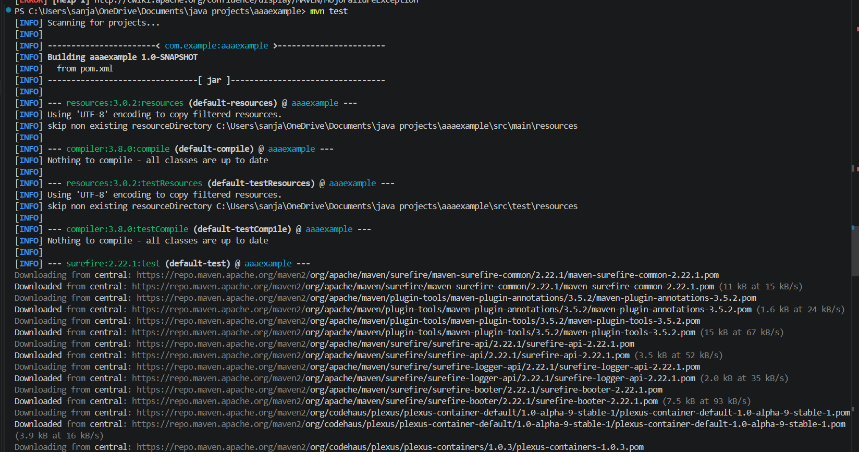
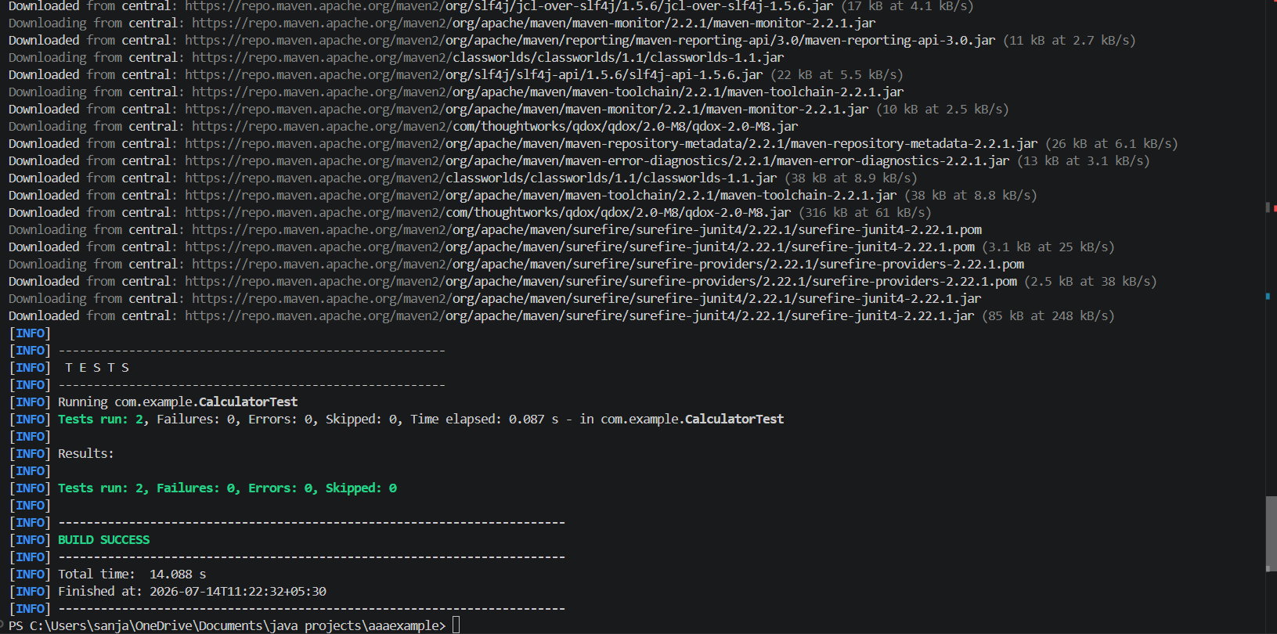
Images:
